Chapter II
Review of the Relevant Literature
As commercial aviation navigates a period of sustained traffic expansion that threatens to outpace the physical limitations of existing terminal infrastructure (Federal Aviation Administration [FAA], 2024; International Air Transport Association [IATA], 2026), the prohibitive financial and spatial costs of continuous brick-and-mortar expansion have shifted operational focus toward software-driven, data-informed terminal capacity management (AlKheder et al., 2024; Balliauw & Onghena, 2020; De Neufville & Odoni, 2014; Ozores, 2026). To address these gaps, researchers are developing models designed to optimize resource allocation, such as staffing and throughput management, while maintaining efficient, high-quality service. When passenger demand surges surpass processing capacity at security screening, congestion ripples backward into ticketing halls and forward into departure concourses, inducing boarding holds, tarmac delays, and passenger misconnections across the system (Adacher et al., 2017). Historically, airport passenger flow modeling prioritized statistical fit and mean throughput optimization under static operating assumptions. However, the unprecedented systemic shocks of the COVID-19 pandemic and subsequent recovery demonstrated that models calibrated solely on clear-weather historical data fail during operational disruptions (Sun et al., 2022). Integrating advanced predictive frameworks offers the potential to build the robust, resilient, and generalizable tools necessary to manage variability and balance competing operational demands under uncertainty.

To address these vulnerabilities, this literature review traces the evolution of airport passenger flow prediction across five core theoretical domains: (a) traditional approaches and operational complexity; (b) simulation modeling and real-time terminal management; (c) advanced predictive; (d) hybrid predictive architectures; (e) the impact of covid; and (f) multi-dimensional operational evaluation, establishing the theoretical foundations for the evaluation trio – Robustness, Resilience, and Generalizability – that governs this research.

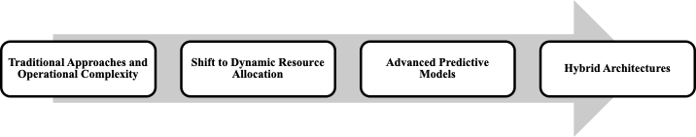

Figure 2.1: Literature Review Outline
Traditional Approaches and Operational Complexity
Commercial airport terminals are complex operational ecosystems where physical infrastructure, traveler behavior, and airline schedules intersect (Birolini & Jacquillat, 2023; Nazir et al., 2022; Zhang et al., 2012). With domestic passenger demand projected to grow by 2.4% annually while physical airport capacity expands by only 0.8%, commercial aviation faces an operational gap that physical construction cannot resolve due to severe financial, spatial, and environmental constraints (Balliauw & Onghena, 2020; FAA, 2024; Fernandes & Pacheco, 2002; IATA, 2026; Lemer, 1988). Consequently, airport research has shifted away from long-term capital expansion toward dynamic landside operational optimization, utilizing computational models to maximize existing terminal footprints (AlKheder et al., 2024; De Neufville & Odoni, 2014; Solak et al., 2009). Historically, terminal planning relied on deterministic formulas assuming that fixed passenger volumes produce predictable, linear service requirements (Parizi & Braaksma, 1994). In operational reality, however, terminal subsystems – specifically check-in halls, security screening checkpoints, and boarding gates – function as highly interdependent, stochastic queuing networks (Araujo & Repolho, 2015). To maintain a target Level of Service (LOS) – the operational benchmark governing acceptable passenger wait times and crowding thresholds – without prohibitive capital investments, terminal operators must actively identify and eliminate transient bottlenecks that restrict passenger throughput (Di Mascio et al., 2020).
The delicate interdependency of airport subsystems further complicates operational shifts, as localized failures in one segment are particularly vulnerable to time-related constraints, potentially triggering a systemic collapse of flow (Orhan & Orhan, 2020; Bießlich et al., 2014; Brown & Madhavan, 2011). Systemic fragility is exacerbated by the interlocking nature of landside and airside events, where a delay in one sector propagates a cascade of congestion across the entire airport ecosystem (Nazir et al., 2022). Furthermore, congestion does not occur linearly; traffic frequently occurs in high concentrations – "starving" capacity for hours before suddenly "saturating" it in minutes – transforming flow optimization into a moving target that outpaces nominal capacity growth (Chiti et al., 2018). Even when a facility remains under its total daily limits, unexpected arrival fluctuations create "ripples" of upstream congestion, inevitably disrupting downstream processes like security screening (Adacher & Flamini, 2020; Marzuoli et al., 2019). This operational friction is intensified by a persistent temporal lag: a systemic mismatch in which the time required to detect a surge forces additional resources to become available only after the peak has subsided. Ultimately, these bottlenecks are rooted in the unpredictable, stochastic nature of passenger behavior, making resource allocation a complex balancing act between operational costs and quality service levels.
Batch Arrival Dynamics and Flight Bank Synchronization
Understanding modern airport capacity and the corresponding resource allocation challenge requires looking beyond the simple reality of demand exceeding supply (Fernandes & Pacheco, 2002). A fundamental operational challenge in airport passenger demand forecasting is that passenger arrivals do not follow a uniform, steady stream. Rather, passenger arrivals are characterized by extreme non-linear fluctuations and concentrated "batches" induced by airline flight bank scheduling (Cheng et al., 2012). Modern hub-and-spoke networks intentionally compress 20 to 40 flight departures into synchronized 45-to-90-minute "flight banks" to maximize connecting passenger transfer opportunities (Schultz & Fricke, 2011). When multiple high-capacity aircraft share overlapping departure banks, thousands of ticketed travelers descend on terminal entrances simultaneously, creating non-linear surges that saturate screening lane capacity far more rapidly than smooth arrival streams (Brunetta et al., 1999; Dönmez et al., 2025; Lemer, 1988; Marzuoli et al., 2019). As Peterson et al. (1995) established in their foundational queuing analysis, flight bank synchronization generates transient, non-stationary queuing states where sudden demand bursts produce congestion that persists long after the scheduled bank has departed.
Classical Queuing Theory: Volume Versus Volatility
To translate unpredictable passenger movements into quantifiable system states, traditional airport planning has utilized Queuing Theory (Horie, 1985; Odoni, 1986). Queuing Theory models how stochastic arrival patterns and concentrated "batches" of passengers interact with various service points throughout the terminal (Wang, 2017). In this framework, every terminal process – from check-in to security screening – is treated as a "server" processing "entities." Early iterations of these models applied a Poisson process distribution to calculate the probability of specific arrival rates within fixed intervals to account for the inherent uncertainty of passenger demand. Poisson arrival distributions (such as M/M/s or M/G/s queuing formulas, which calculate queue lengths and wait times based on assumed random arrival rates and screening speeds) have been used to balance operational staffing costs against target Level of Service benchmarks (Araujo & Repolho, 2015). However, classical Poisson models rest on the assumption of a constant, time-invariant arrival rate (λ), and consequently consistently struggle to reflect non-linear dynamics and dramatic fluctuations triggered by flight banks (Wang, 2018).
Within an operational context, flight banks act as the primary driver of "batch behavior" in terminal queues (Peterson et al., 1995). Concentration of demand forces the system to process massive, non-linear surges that can saturate capacity far more rapidly than a steady, continuous stream. To address this, researchers transitioned toward Non-Homogeneous Poisson Processes (NHPP) and multiphase networks, allowing arrival rates to vary across sequential service intervals (Brunetta et al., 1999; Hess & Grbčić, 2019). NHPP formulations are constrained due to a dependence on expected mean volume and the assumption of independent arrivals, failing to account for the high correlation among passengers arriving for the same ticketed flight bank and ignoring the impact of airside connecting passengers (Adeke, 2018; Guo et al., 2022). Data-driven queuing models and bottleneck detection algorithms consistently identified passenger security checkpoints as the primary decelerators of overall terminal throughput (Alnowibet et al., 2022; Liu, 2018; Lu et al., 2018; Nikoue et al., 2015). Generalized Stochastic Petri Nets (GSPN) were subsequently applied to reduce "dead time" between screening stages to increase checkpoint service rates (Wei, 2017; Zhang et al., 2017), while likelihood-free inference methods were introduced to better estimate time-varying network flows (Ebert et al., 2021).
The "Values versus Volatility" Paradigm in Transportation Demand
In operational reality, heavy-traffic queuing principles demonstrate that checkpoint wait times and passenger lines do not depend solely on average passenger volume, but on the irregularity and burstiness of passenger arrivals and processing speeds (Kingman, 1961; Whitt, 1993). As checkpoint lanes operate near full capacity during morning and evening departure peaks, any sudden increase in passenger arrival swings causes wait times and crowd congestion to grow exponentially (Adeke, 2018; Guo et al., 2022). This dynamic establishes the "Values versus Volatility" paradigm in transportation demand, which manifests across two operational horizons (Andersen & Bollerslev, 1998; Engle, 2001; Hansen & Lunde, 2005). First, over intraday hourly horizons, passenger volume swings naturally expand alongside total flight traffic, allowing scheduled seat counts alone to serve as a dependable baseline predictor for routine daily flow. Second, across multi-day horizons, published flight schedules remain largely unchanged, meaning that anticipating disruption-driven passenger turbulence requires tracking the volatility of operational disruptions – specifically flight cancellations, schedule instability, and departure delay spreads – rather than relying solely on static flight volumes (Hopfe et al., 2024).
From Analytical Queuing Models to Simulation Modeling and Real-Time Management
Micro-Simulation in Terminal Planning and Asset Allocation
To overcome the rigid mathematical assumptions of analytical queuing equations, airport planners widely adopted micro-simulation – a modeling approach that simulates individual system entities rather than aggregate flows – primarily implemented through Discrete Event Simulation (DES) (Brown & Madhavan, 2011; Leone & Liu, 2011; Verki et al., 2013). Unlike static spreadsheets, DES models track individual simulated travelers chronologically through discrete physical milestones: ticket verification, divestiture (removing shoes, outer garments, laptops, and liquids for X-ray inspection), body scanning, and item retrieval. By acting as the underlying engine, DES provides the simulation capabilities necessary for a broader Digital Twin framework: a continuously updated virtual replica that mirrors physical infrastructure in real-time (Edwards, 2026). In operational planning, these micro-simulation frameworks proved highly effective for static terminal dimensioning. Guizzi et al. (2009) demonstrated that simulating passenger trajectories from check-in through security screening allowed planners to model queuing interdependencies, while Parlar et al. (2016) used event-based simulations to optimize dynamic counter opening schedules. Furthermore, Nwofia and Chung (2013) highlighted the utility of simulation in linking terminal architectural layouts to long-term service performance, enabling airport authorities to evaluate proposed flight schedules and lane configurations under synthetic operating loads (Araujo & Repolho, 2015; Ateş et al., 2021).
Stochastic planning methodologies (Verki et al., 2013), virtual terminal infrastructure tracking (Edwards, 2026), and simulated human behavioral loads (Perez, 2021) supported asset distribution, while algorithm-based congestion detection (Palaşcă & Stăncel, 2025) recontextualized Poisson queuing within dynamic monitoring frameworks. Additionally, simulation environments such as ARENA (Olusanya et al., 2020; Oprea et al., 2024) and simulation data farming (Patrón et al., 2021) have served as offline synthetic data generators for evaluating security subsystems. While Discrete Event Simulation (DES) achieves granular physical fidelity across screening lane subsystems, predefined logic structures impose critical operational constraints on real-time checkpoint management. Table 2.1 synthesizes the primary operational limitations of micro-simulation identified in the terminal planning literature.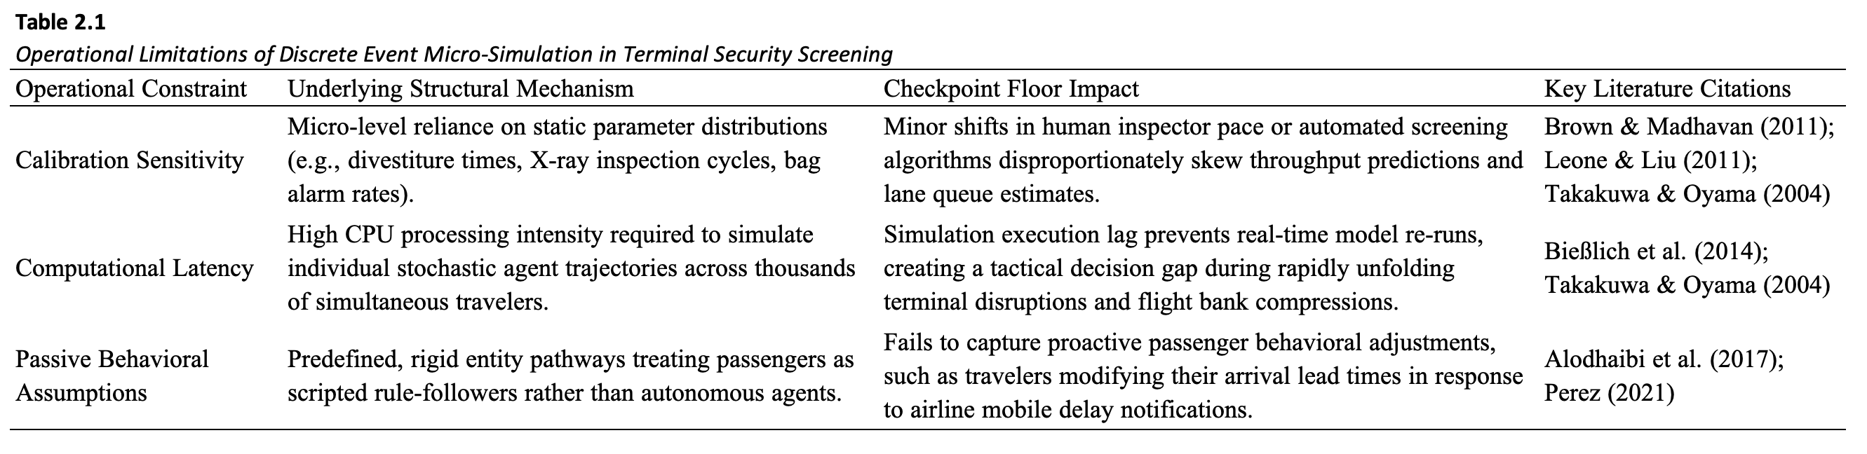
Advanced Predictive Models and Machine Learning
The adoption of Artificial Intelligence (AI) represents the technical realization of this shift through Machine Learning (ML), a subset of AI that moves beyond pre-programmed rules to serve as a pattern-recognition tool capable of managing the stochastic "noise" of passenger behavior (Saki & Soori, 2026). Unlike the rigid nature of early discrete event simulations, these modern architectures serve as the foundation for robust resource allocation by absorbing vast streams of real-time data to forecast emergent behaviors. This evolution represents a fundamental move toward probabilistic reasoning, where the objective is to model the likelihood of various outcomes rather than relying on a single deterministic path.
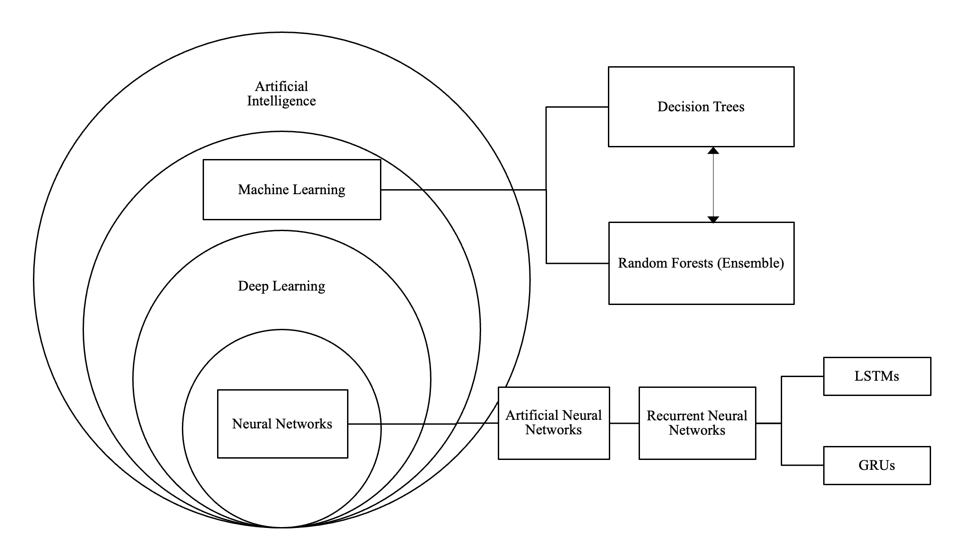
Figure 22. Artificial Intelligence Hierarchy
Statistical Time-Series Foundations and Linear Limitations
To achieve faster, automated forecasts without the computational latency of micro-simulation, transportation planners turned to empirical time-series models, such as Autoregressive Integrated Moving Average (ARIMA) and Seasonal ARIMA (SARIMA) formulations (Box et al., 2015; Hyndman & Athanasopoulos, 2018; Li et al., 2017). SARIMA models have been used to identify recurring patterns by analyzing the internal properties of a univariate time series, such as the autocorrelation of past arrival waves and daily seasonal cycles. By mathematically 'averaging' its own historical errors and trends, SARIMA effectively captures the predictable rhythms of flight banks and holiday travel (Babu, 2014). However, while SARIMA excels at internal pattern recognition, because it relies on historical data, it does not account for the direct correlation between fluctuating passenger volumes and specific, real-time flight arrangements (Lin et al., 2023).
Non-Linear Machine Learning: Deep Learning Versus Tree Ensembles
To model complex non-linear relationships that linear statistical models cannot represent, recent aviation literature has explored machine learning algorithms, including deep sequence models such as Long Short-Term Memory (LSTM) recurrent networks, Gated Recurrent Units (GRU), and tree ensembles like Gradient-Boosted Decision Trees (GBM) (Hopfe et al., 2024; Ribeiro et al., 2025). Unlike traditional SARIMA models, LSTMs can learn complex, non-linear long-term dependencies between past arrival waves and future terminal surges, effectively reflecting the external influences that statistical models tend to overlook (Hewamalage et al., 2021). While Orsini et al. (2019) highlight the necessity of the recurrent nature of LSTMs for predicting real-time passenger journeys, the computational demands of such models limit their strategic application. Consequently, dense neural networks provide a computationally efficient alternative for capturing the non-linear surges inherent in airport traffic; a compact, dense architecture achieves high-fidelity forecasting with minimal overhead. Simulation data farming underpins the enhancement of robustness in these predictive tools, offering a pathway to generate the vast datasets necessary for training machine learning models within elaborate security subsystems (Patrón et al., 2021). Although deep sequence neural networks (e.g., LSTM, GRU, Transformers) effectively capture high-dimensional non-linear interactions, their deployment in commercial airport security environments is constrained by administrative and structural barriers. Table 2.2 summarizes the operational limitations of deep neural architectures in terminal throughput forecasting.
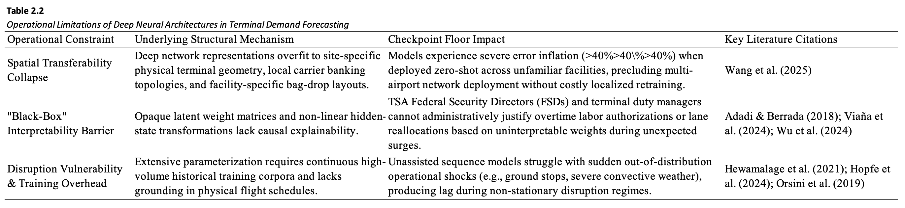
From Passive Prediction to Behavioral Modeling and Active Control
Recognizing the limits of passive flow prediction, recent transportation literature has explored active control frameworks where predictive models inform real-time operational decisions. Multi-agent reinforcement learning has been utilized to model proactive passenger navigation under terminal constraints (Li & Gao, 2023), although Anagnostopoulou et al. (2024) documented persistent functional gaps in capturing actual flow volumes. To bridge the gap between prediction and tactical intervention, Diaz-Gutierrez et al. (2025) developed Model Predictive Control (MPC) algorithms that integrate stochastic terminal dynamics into automated resource optimization loops. Concurrently, Lee et al. (2025) and Yang et al. (2022) formulated dynamic passenger guidance and rescheduling strategies to balance crowding across parallel departure checkpoints in real time. These active control formulations demonstrate that high-utility forecasting tools must provide transparent, actionable inputs that align directly with operational decision rules.
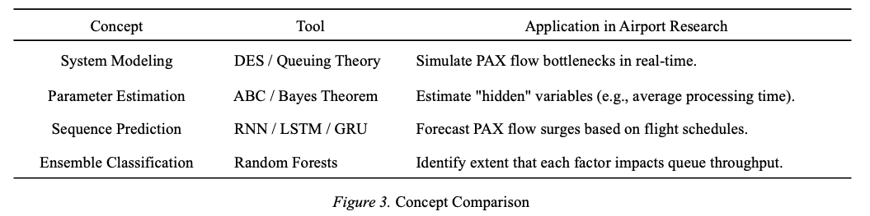
Hybrid Architectures: Combining Operational Structure with Data-Driven Adaptability
To resolve the "black-box" challenge – where the internal logic of deep learning models is difficult to interpret – researchers increasingly advocate for hybrid architectures that couple data-driven prediction with physical constraints (Adadi & Berrada, 2018; Jenčová et al., 2025). In early hybrid formulations, neural network flow forecasts are passed to secondary optimization layers – such as Simulated Annealing or Integer Linear Programming (ILP) – to enforce checkpoint throughput limits and determine staffing buffers (Brun et al., 2025). Similarly, combining Random Forest predictions with deterministic queue-length models translates broad passenger volumes into actionable, flight-level wait-time insights (Had et al., 2025).
To improve predictive stability across varying conditions, recent research integrates deep learning with exogenous covariates and queuing dynamics. Hopfe et al. (2024) demonstrated that combining Gated Recurrent Units (GRU) with gradient boosting improves forecast accuracy by incorporating external variables, such as weather and mobile search behavior. Ribeiro et al. (2025) showed that embedding queuing-theoretic features directly into Gradient Boosting Machines (GBM) captures non-linear congestion dynamics far better than unassisted models. To capture multi-scale patterns, the Fusion Intelligence Network Model (FINM) proposed by He et al. (2024) combines Convolutional Neural Networks (CNN) for spatial feature extraction, Bidirectional LSTMs (BiLSTM) for temporal context, and GRUs for computational efficiency, maintaining stability under rapidly shifting terminal traffic.
Despite their predictive power, multi-layered networks lack straightforward interpretability, presenting a major barrier for airport operators who must understand the causal mechanism behind unexpected passenger surges (Viaña et al., 2024; Wang et al., 2025). To achieve causal interpretability, "glass-box" Bayesian Networks (BNs) represent probabilistic dependencies through explicit cause-and-effect structures. Guo et al. (2025) extended this framework by coupling Bayesian Networks with the Best-Worst Method, quantifying interdependencies among terminal resilience factors to capture both physical facility constraints and human variability. Similarly, Hybrid Queue-based Bayesian Networks (HQBN) blend classical queuing theory with probabilistic reasoning to diagnose the root causes of congestion across sequential screening stages, enabling explainable decision-making for tactical resource allocation (Wu et al., 2014).
Managing operational uncertainty further requires stochastic optimization and empirical validation. Metaheuristic algorithms, particularly Particle Swarm Optimization with Back Propagation (PSO-BP), tune neural network parameters without exhaustive search, improving performance on non-linear baggage flows and screening wait times (Jiang et al., 2024; Naji et al., 2020; Sörensen, 2015; Wu, 2024). Under noisy operational data, likelihood-free inference estimates system dynamics during unpredictable disruptions (Ebert et al., 2021), while Nonlinear Autoregressive with Exogenous Input (NARX) models incorporate weather covariates to improve forecast transparency (Anupam & Lawal, 2024). These predictive components are commonly benchmarked within simulation platforms like ARENA to validate physical queue behavior (Olusanya et al., 2020; Oprea et al., 2024). Furthermore, Fuzzy Logic systems model subjective passenger decision-making under uncertainty, enabling real-time terminal routing toward underutilized checkpoints (Blasco-Puyuelo et al., 2023; Xia et al., 2020; Yang et al., 2022). Ultimately, because complex models often trade interpretability for statistical fit, operational deployment necessitates architectures that balance predictive accuracy with transparency (Wu et al., 2024).
During operational disruptions – such as flight delays and cancellations – supervised tree ensembles (Gradient-Boosted Decision Trees or Random Forests) predict the residual error between scheduled demand and actual throughput (Brun et al., 2025; Hopfe et al., 2024; Ribeiro et al., 2025). Decision trees provide intuitive, auditable branching rules that terminal managers can inspect during severe weather events. Finally, during catastrophic ground stops where static schedules collapse and falsely predict zero demand (the "Empty Checkpoint Fallacy"), incorporating recursive real-time error feedback allows models to monitor live checkpoint sensors and dynamically update queue states, ensuring rapid recovery (Anupam & Lawal, 2024; Ebert et al., 2021; Wu et al., 2024; see Appendix for comparative paradigm taxonomy).
The Impact of Post-Pandemic Operational Volatility
While predictive modeling for airport passenger flow utilizes probabilistic methods capable of processing both pre-pandemic and pandemic data, the unprecedented operational shocks of COVID-19 revealed a critical vulnerability in how these models are evaluated (Sun et al., 2022). Existing frameworks proved ill-equipped to account for extreme, abrupt disruptions in the commercial air traffic industry. The pandemic fundamentally altered terminal operations as airports were driven to restructure passenger handling, shifting priorities away from speed-centric throughput toward the minimization of public health risks (Mota et al., 2021). As even highly sophisticated models struggled to accurately forecast flow amidst these profound spatial and procedural changes, it became evident that raw predictive accuracy could no longer serve as the sole benchmark for a model's efficacy (Li et al., 2023). Consequently, the systemic disruptions of COVID-19 drove a paradigm shift in airport passenger flow operations, prioritizing robustness, resilience, and generalizability as primary evaluation criteria.
Robustness to Procedural Volatility (Performance Under Perturbation)
The rapid adoption of digital and self-service processes initially introduced highly volatile processing times, transforming automation from a reliable accelerator into a potential operational bottleneck (Lin, 2022). Consequently, predictive models must now be evaluated on their robustness—their capacity to adapt to sudden shifts and treat these dynamic, unpredictable processing times as active variables rather than stable baselines.
Resilience to Systemic Shocks (Capacity to Absorb and Recover from Disruption)
Terminals witnessed the emergence of decentralized queue structures, physical barriers, and curtailed staffing levels to align with diminished and unpredictable passenger demand (Schultz et al., 2021; Kazda et al., 2022). This structural upheaval necessitates an emphasis on resilience, ensuring models can withstand severe systemic shocks and accurately map extreme demand fluctuations alongside sudden physical capacity constraints.
Generalizability Across Environments (External Validity)
The pandemic revealed that ostensibly "similar" airports harbored drastically different underlying structural vulnerabilities, demonstrating that comparable variables could not uniformly explain the volatility of passenger flow across different hubs (Güner & Seçkin Codal, 2024). Moreover, confounding factors - such as simultaneous capacity-altering construction at specific airports or industry-wide shifts in flight schedules - proved that evaluating raw throughput without contextualizing infrastructure changes leads to flawed assumptions. As a result, models must be highly generalizable across structurally diverse terminal environments to effectively decouple the relationship between flight schedules and actual operational throughput (Tang et al., 2023).

